半自动搓滚贴标机 -T312
Semi-automatic Rolling Labeling Machine -T312
Committed to the research and development of labeling and packaging equipment, promoting the development of technology intelligent products
致力于贴标包装设备研发，推动科技智能化产品发展

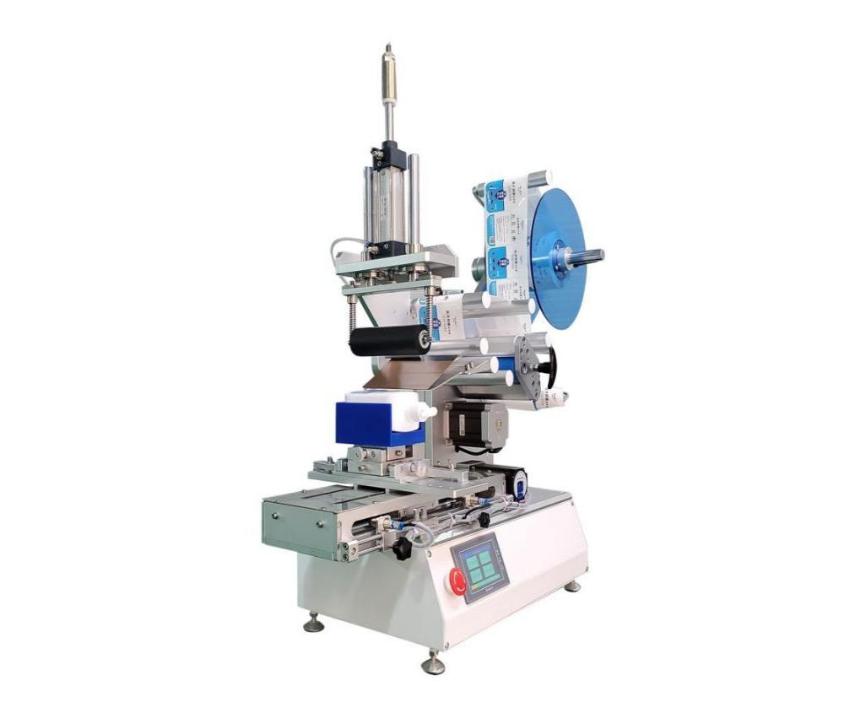
设备用途 Equipment use
采用滚贴方式贴标，无论标签大小，贴标都非常稳定；膜类（透明标签）贴标无气泡，满足各种产品贴标要求。适用于在产品的上平面、弧面、凹面贴标，贴标精度高达±0.5mm,
The labeling method of roll-on labeling is very stable regardless of label size; film (transparent label) labeling without bubbles, to meet the labeling requirements of various products. Suitable for labeling on the upper plane, curved surface and concave surface of products, with labeling accuracy up to ±0.5mm.



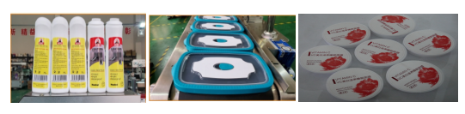

设备参数 Equipment parameters
贴标精度： ±0.5mm (不含产品、标签误差)；
Labeling accuracy: ±0.5mm (excluding product, label error);
贴标速度 ：15～30件/分钟（与产品尺寸有关）；
Labeling speed ： 15～30 pieces/min (related to product size);
适用产品尺寸：长度：20mm～200mm 宽度：20mm～180mm 高度：5mm～130mm
Applicable product size: Length: 20mm～200mm Width: 20mm～180mm Height: 5mm～130mm
适用标签尺寸：长度：15mm～300mm 底纸宽度：15mm～150mm
Applicable label size: Length: 15mm ~ 300mm Width of backing paper: 15mm ~ 150mm
整机尺寸： 约880mm×550mm×880mm（长×宽×高）
Overall machine size: 880mm×550mm×880mm (L×W×H)
适用电源： 110-220V/50HZ；
Applicable power supply: 110-220V/50HZ;
气压（Mpa）：0.4～0.6Mpa
Air pressure (Mpa): 0.4～0.6Mpa
整机重量： 约60Kg。
Weight of the whole machine: about 60Kg.
适用标签内径：Ø76mm
Applicable label inner diameter: Ø76mm
适用标签外径：Ø 300mm
Applicable label outer diameter: Ø 300mm

智能半自动多功能贴标机-T316
Intelligentsemi-automaticmulti-functionallabeling machine-T316
设备用途 Equipment use
应用滚贴方法贴标，实现在各种产品上贴标，如扁瓶、圆瓶、方瓶、六角瓶、锥度瓶、棱形瓶或不规则瓶等贴标,滚贴原理贴标，贴标稳定，贴标无气泡，精度高.
Application of roll-on labeling method to achieve labeling on a variety of products, such as flat bottles, round bottles, square bottles, hexagonal bottles, tapered bottles, prismatic bottles or irregular bottles labeling, roll-on principle labeling, labeling stability, labeling without bubbles, high precision.

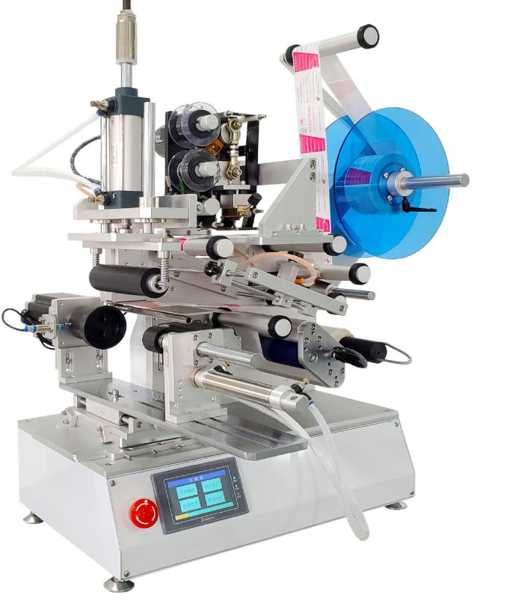

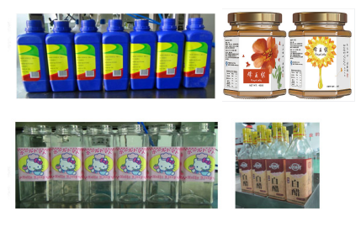
设备参数 Equipment parameters
贴标精度： ±0.5mm (不含产品、标签误差)；
Labeling accuracy: ±0.5mm (excluding product, label error);
贴标速度： 15～30件/分钟（与产品尺寸有关）；
Labeling speed: 15～30 pieces/min (related to product size);
适用产品尺寸：长度：20mm～200mm 宽度：20mm～180mm 高度：5mm～130mm
Applicable product size: Length: 20mm～200mm Width: 20mm～180mm Height: 5mm～130mm
适用标签尺寸：长度：15mm～300mm 底纸宽度：15mm～150mm
Applicable label size: Length: 15mm～300mm Backing width: 15mm～150mm
整机尺寸： 约880mm×550mm×880mm（长×宽×高）
Overall machine size: about 880mm×550mm×880mm (L×W×H)
适用电源： 110-220V/50HZ；
Applicable power supply: 110-220V/50HZ;
气压（Mpa）：0.4～0.6Mpa
Air pressure (Mpa): 0.4～0.6Mpa
整机重量： 约60Kg。
Weight of the whole machine: about 60Kg.
适用标签内径：Ø76mm 适用标签外径：Ø 300mm
Applicable label inner diameter: Ø76mm Applicable label outer diameter: Ø 300mm

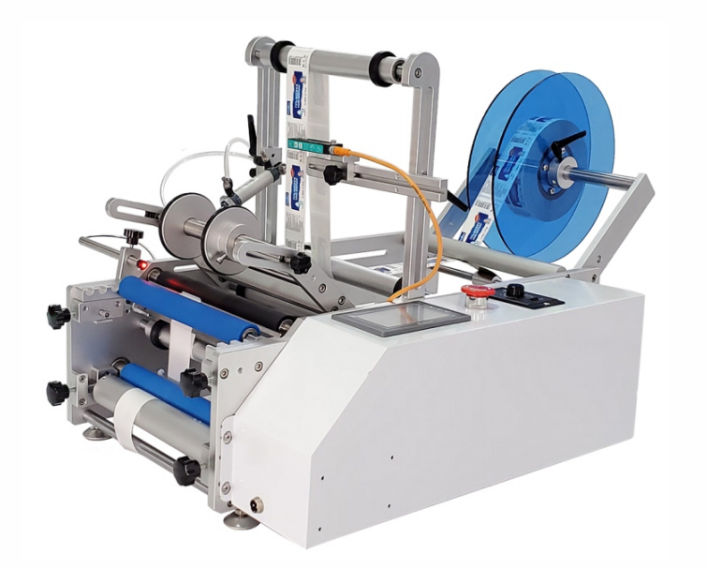
设备用途 Equipment use
设备广泛应用于各种规格的圆柱形物体贴标，小锥度圆瓶贴标，可实现全周/半周贴标、圆周正背面贴标， 正背标间距可任意调整。可选配圆周定位检测装置，实现圆周定点贴标；可选配色带打码机贴标同时打生产日期、有效期、批号等信息，减少包装工序，提高生产效率。设备稳定性高、贴标效果好，贴标精度±0.5mm。
The equipment is widely used in labeling cylindrical objects of various specifications and small tapered round bottles, and can realize full/ half circumference labeling, circumferential front and back labeling, and the spacing between front and back labels can be adjusted arbitrarily. Optional circumferential positioning detection device to achieve circumferential spot labeling; optional ribbon coding machine labeling at the same time to play the production date, expiration date, batch number and other information to reduce the packaging process and improve production efficiency. High stability of equipment, good labeling effect, labeling accuracy ± 0.5mm.

智能半自动圆瓶贴标机-T413
Intelligent semi-automatic round bottle labeling machine-T413

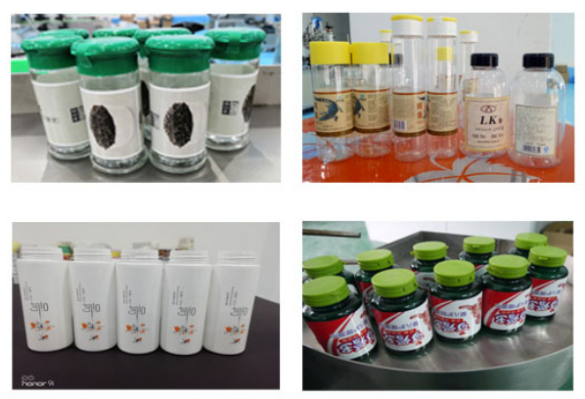
设备参数 Equipment parameters
贴标精度： ±0.5mm (不含产品、标签误差)；
Labeling accuracy: ±0.5mm (excluding product, label error);
贴标速度： 15～30件/分钟（与产品尺寸有关）；
Labeling speed: 15～30 pieces/min (related to product size);
适用产品尺寸： Ø 15mm～Ø 100mm；
Applicability specifications:Ø 15mm ～Ø 100mm;
适用标签尺寸：（L）20mm-200mm;(w)10mm-180mm
Applicable label size:（L）20mm-200mm;(w)10mm-180mm
整机尺寸： 约900mm×550mm×550mm（长×宽×高）
Overall machine size: about900mm×550mm×550mm (L×W×H)
适用电源： 110-220V/50HZ；
Applicable power supply: 110-220V/50HZ;
气压（Mpa）：0.4～0.8Mpa
Air pressure (Mpa): 0.4～0.8Mpa
整机重量： 约60Kg。
Weight of the whole machine: about 60Kg.
适用标签内径：Ø76mm
Applicable label inner diameter: Ø76mm
适用标签外径：Ø 300mm
Applicable label outer diameter: Ø 300mm

全自动智能搓滚贴标机-T211
Automatic Intelligent Rolling Labeling Machine-T211
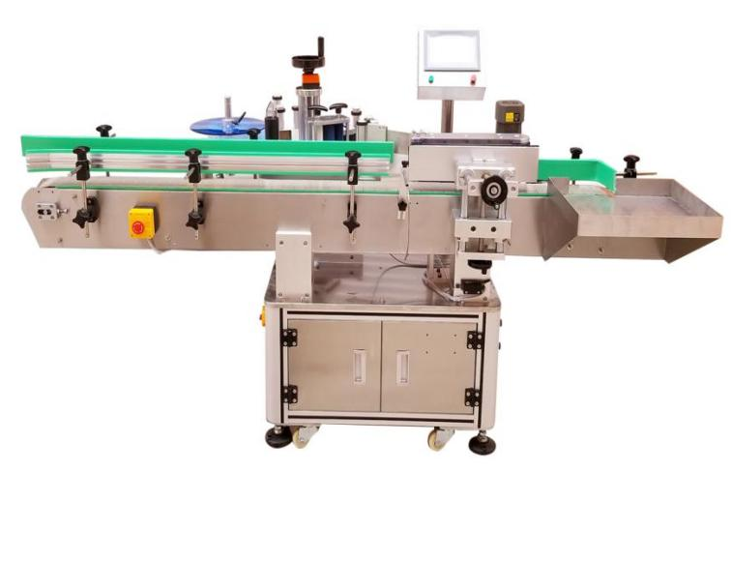

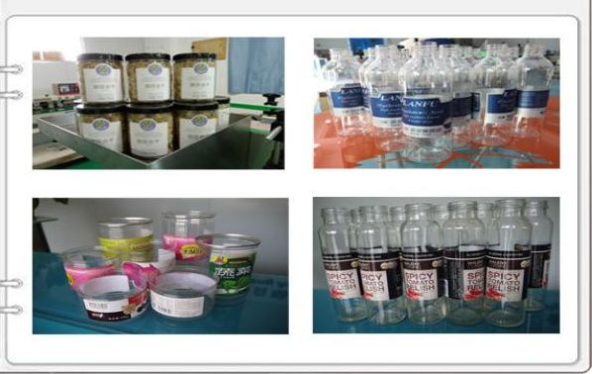

设备参数 Equipment parameters
贴标精度： ±1mm (不含产品、标签误差)；
Labeling accuracy: ±1mm (excluding product, label error);
贴标速度：20～100pcs/min（与产品标签尺寸有关）
Labeling speed: 20 ~ 100pcs/min (related to the size of the product label)
适用标签规格：(L)20mm-200mm;(w)20mm-180mm
Applicable label specifications:(L)20mm-200mm;(w)20mm-180mm
适用产品规格：：Ø 25mm～Ø 100mm；（可根据样品定做）
Applicable product specifications: Ø 25mm～Ø 100mm; (can be customized according to samples)
整机尺寸：（L）1800*(W)1150*(H)1450mm（长×宽×高）
Overall machine size: about1180mm×1150mm×1450mm (L×W×H)
适用电源： 110-220V/50HZ；
Applicable power supply: 110-220V/50HZ;
整机重量： 约180Kg。
Weight of the whole machine: about 180Kg.
适用标签内径：Ø76mm 适用标签外径：Ø 300mm
Applicable label inner diameter: Ø76mm Applicable label outer diameter: Ø 300mm

设备用途 Equipment use
本设备主要针对规则圆瓶且材质较硬不易变形的产品不需要定位的圆周高速贴标，如化妆品、食品、医药、日 化、电子、玩具、五金、塑胶等行业中，可实现全周/半周贴标，规则类产品大小兼容范围广，贴标效率高。适用圆瓶，四方瓶，六角瓶等贴标。
可选 配色带打码机和喷码机，贴标同时实现打印生产批号、生产日期等信息，实现贴标-喷码一体化，减少包装工序， 提高生产效率。适用不干胶标签、不干胶膜、电子监管码、条形码、二维码标签、透明标签等。设备稳定性高、贴 标效果好，无气泡、无褶皱，贴标精度±1mm
The equipment is mainly for regular round bottles and hard material is not easy to deform the product does not need to position the circumferential high-speed labeling, such as cosmetics, food, medicine, daily chemical, electronics, toys, hardware, plastic and other industries, can achieve the full circumferential / semi circumferential labeling, the size of regular products compatible with a wide range, high labeling efficiency. It is suitable for labeling round bottles, quadrilateral bottles, hexagonal bottles, etc.
It can be equipped with ribbon coder and inkjet printer to print production batch number, production date and other information at the same time, realizing the integration of labeling and inkjet coding, reducing packaging process and improving production efficiency. Suitable for self-adhesive labels, self-adhesive film, electronic supervision code, bar code, two-dimensional code labels, transparent labels, etc. High stability of equipment, good labeling effect, no bubbles, no wrinkles, labeling accuracy ± 1mm

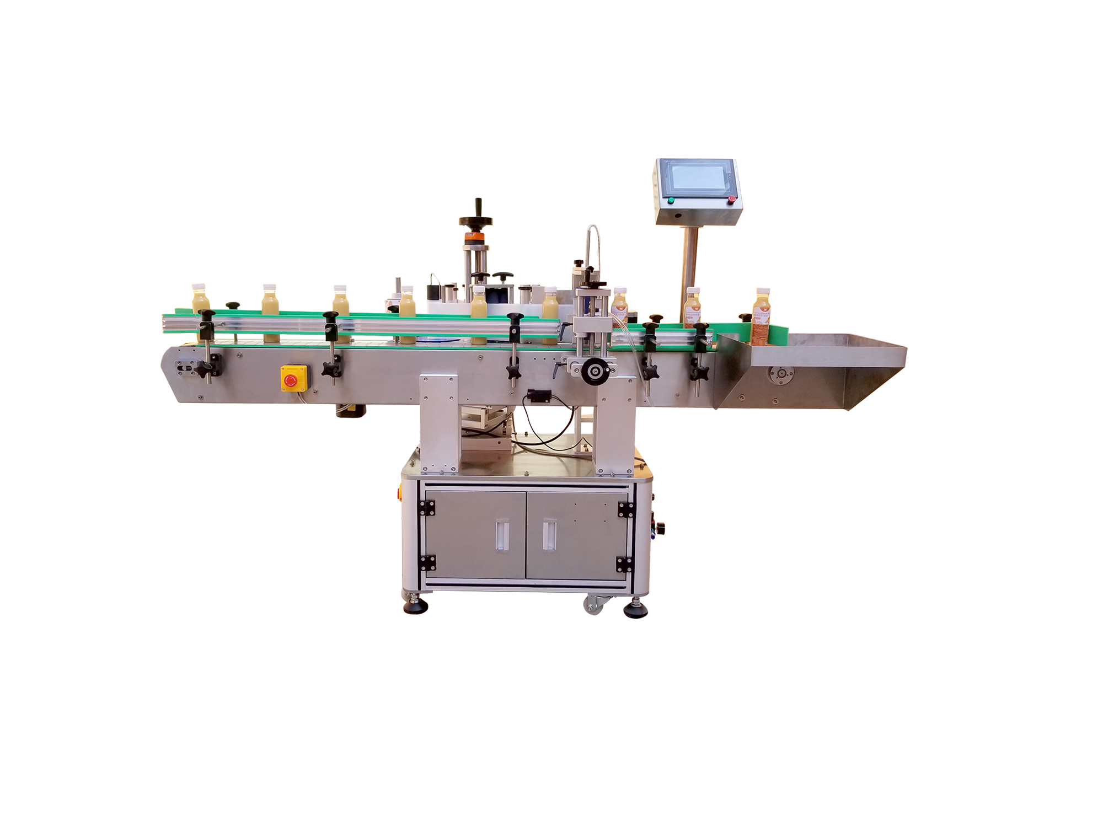
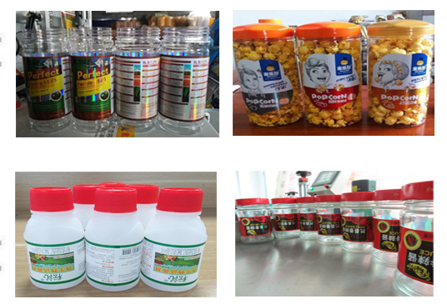
智能自动定位圆瓶贴标机-T212
Intelligent automatic positioning round bottle labeling machine-T212

设备用途 Equipment use
本设备广泛应用于各种规格的圆周面物体贴标，锥度圆瓶贴标，如化妆品、食品、医药、日化、玩具、五金、 塑胶等行业中，可实现全周/半周贴标、圆周正背面双标贴标，正背标间距可任意调整。可选配圆周定位检测装置，实现圆周定位贴标。可选配色带打码机和喷码机，贴标同时实现打印生产批号、生产日期等信息，实现贴标-喷码 一体化，减少包装工序，提高生产效率。适用不干胶标签、不干胶膜、电子监管码、条形码、二维码标签、透明标签等。设备稳定性高、贴标效果好，无气泡、无褶皱，贴标精度±1mm
This equipment is widely used in labeling of various specifications of circumferential objects, tapered round bottle labeling, such as cosmetics, food, pharmaceutical, daily chemical, toys, hardware, plastic and other industries, can achieve full circumference / half circumference labeling, circumferential front and back double label labeling, front and back label spacing can be arbitrarily adjusted. Optional circumferential positioning detection device to achieve circumferential positioning labeling. Optional ribbon coding machine and inkjet printer can be used to print the production batch number and production date at the same time, which can realize the integration of labeling and inkjet coding, reduce the packaging process and improve the production efficiency. Suitable for self-adhesive labels, self-adhesive film, electronic supervision code, bar code, two-dimensional code labels, transparent labels, etc. High stability of equipment, good labeling effect, no bubble, no wrinkle, labeling accuracy ±1mm

设备参数 Equipment parameters
贴标精度： ±1mm (不含产品、标签误差)；
Labeling accuracy: ±1mm (excluding product, label error);
贴标速度：20～60pcs/min（与产品标签尺寸有关）
Labeling speed: 20 ~ 60pcs/min (related to the size of the product label)
适用标签规格：(L)20mm-200mm;(w)20mm-180mm
Applicable label specifications:(L)20mm-200mm;(w)20mm-150mm
适用产品规格：：Ø 25mm～Ø 110mm； （可根据样品定做）
Applicable product specifications:Ø 25mm～Ø 110mm; (can be customized according to samples)
整机尺寸：（L）1800*(W)1150*(H)1450mm（长×宽×高）
Overall machine size: about 1800mm×1150mm×1450mm (L×W×H)
适用电源： 110-220V/50HZ；
Applicable power supply: 110-220V/50HZ;
气压（Mpa）：0.4～0.6Mpa
Air pressure (Mpa): 0.4～0.6Mpa
整机重量： 约180Kg。
Weight of the whole machine: about 180Kg.
适用标签内径：Ø76mm 适用标签外径：Ø 300mm
Applicable label inner diameter: Ø76mm Applicable label outer diameter: Ø 300mm

智能全自动卧式圆瓶贴标机-T219
Intelligent automatic horizontal round bottle labeling machine-T219
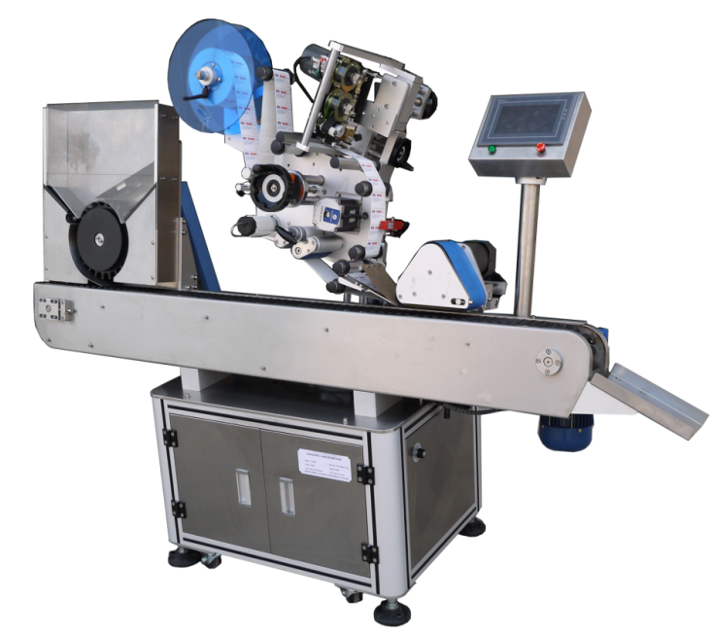

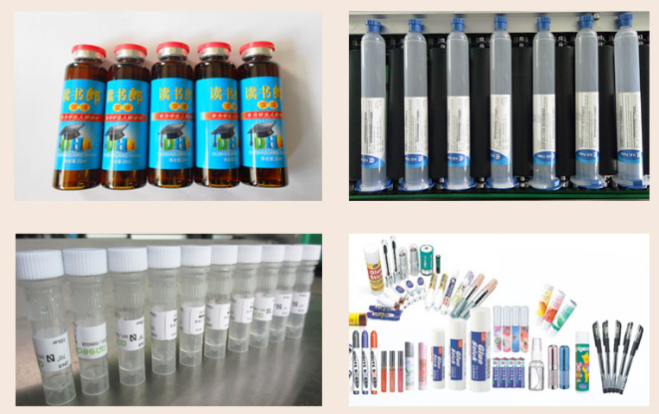

设备用途 Equipment use
本设备适用于各种站立不稳的圆柱形物体的圆周或半圆周贴标。广泛应用于化妆品、食品、医药、日化、电子、 玩具、五金、塑胶等行业中，可实现全周/半周贴标。采用卧式传送、卧式贴标的方式，增加稳定性，提高贴标效率。
适用不干胶标签、不干胶膜、电子监管码、条形码、二维码标签、透明标签等。设备稳定 性高、贴标效果好，无气泡、无褶皱，贴标精度±0.5mm
This equipment is suitable for labeling all kinds of cylindrical objects with unstable standing circumference or semi-circular circumference. Widely used in cosmetics, food, medicine, daily chemical, electronics, toys, hardware, plastic and other industries, it can realize full circumference / semi circumference labeling. It adopts horizontal transmission and horizontal labeling method to increase stability and labeling efficiency.
Suitable for self-adhesive labels, self-adhesive film, electronic supervision code, bar code, two-dimensional code labels, transparent labels, etc. High stability of equipment, good labeling effect, no bubble, no wrinkle, labeling accuracy ±0.5mm

设备参数 Equipment parameters
贴标精度： ±0.5mm (不含产品、标签误差)；
Labeling accuracy: ±0.5mm (excluding product, label error);
贴标速度：40～300pcs/min（与产品标签尺寸有关）
Labeling speed: 40 ~ 300pcs/min (related to the size of the product label)
适用标签规格：(L)20mm-100mm;(w)20mm-900mm
Applicable label specifications:(L)20mm-100mm;(w)20mm-90mm
适用产品规格：：Ø 10mm～Ø 30mm； （可根据样品定做）
Applicable product specifications:Ø 10mm～Ø 30mm; (can be customized according to samples)
整机尺寸：（L）2000*(W)850*(H)1450mm（长×宽×高）
Overall machine size: about2000mm×850mm×1450mm (L×W×H)
适用电源： 110-220V/50HZ；
Applicable power supply: 110-220V/50HZ;
整机重量： 约200Kg。
Weight of the whole machine: about 200Kg.
适用标签内径：Ø76mm
Applicable label inner diameter: Ø76mm
适用标签外径：Ø 300mm
Applicable label outer diameter: Ø 300mm

全自动平面贴标机-T113
Fully automatic flat labeling machine -T113
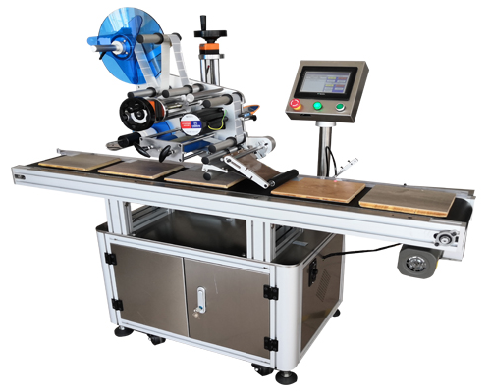

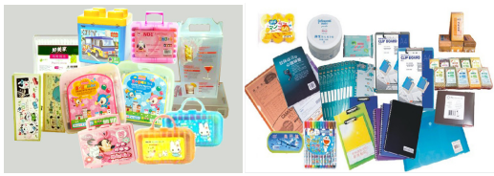

设备用途 Equipment use
本设备广泛应用于化妆品、食品、医药、日化、电子、玩具、五金、塑胶等行业中，采用滚贴方式贴标，可实现在各种平面贴标,更换覆标机构可满足不平整表面贴标；适用 不干胶标签、不干胶膜、电子监管码、条形码、二 维码标签等。设备稳定性高、贴标效果好，无气泡、无褶皱，贴标精度±1mm。3
The equipment is widely used in cosmetics, food, medicine, daily chemical, electronics, toys, hardware, plastic and other industries, using the roll-on labeling method, can be achieved in a variety of flat labeling, replace the labeling mechanism to meet the uneven surface labeling; suitable for self-adhesive labels, self-adhesive film, electronic supervision code, bar code, two-dimensional code labels. High stability of equipment, good labeling effect, no bubble, no wrinkle, labeling accuracy ± 1mm.

设备参数 Equipment parameters
贴标精度： ±0.5-1mm (不含产品、标签误差)；
Labeling accuracy: ±0.5-1mm (excluding product, label error);
贴标速度：40～200pcs/min（与产品标签尺寸有关）
Labeling speed: 40 ~ 200pcs/min (related to the size of the product label)
适用标签规格：(L)20mm-250mm;(w)20mm-150mm
Applicable label specifications:(L)20mm-250mm;(w)20mm-150mm
适用产品规格：：（L)40mm-400mm (W)30mm-200mm (H)0.2mm-150mm
Applicable product specifications（L)40mm-400mm (W)30mm-200mm (H)0.2mm-150mm
整机尺寸：约（L）1600*(W)850*(H)1450mm（长×宽×高）
Overall machine size: about 1600mm×850mm×1450mm (L×W×H)
适用电源： 110-220V/50HZ；
Applicable power supply: 110-220V/50HZ;
整机重量： 约180Kg。
Weight of the whole machine: about 180Kg.
适用标签内径：Ø76mm
Applicable label inner diameter: Ø76mm
适用标签外径：Ø 300mm
Applicable label outer diameter: Ø 300mm

智能自动分页贴标机-T115
Intelligent automatic paging and labeling machine-T115
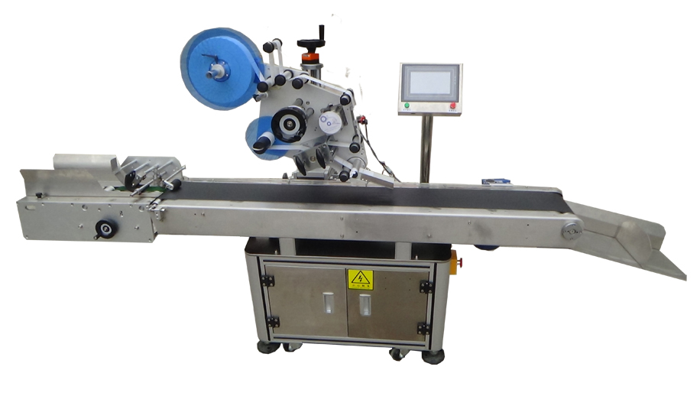

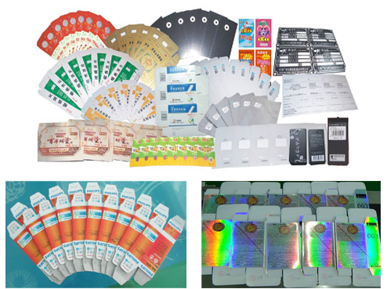

设备用途 Equipment use
设备是独家新型升级版分卡机构， 分卡稳定。可满足各种卡片、吊牌，食品袋，防静电袋、纸片、纸板贴标、压克力贴膜、大塑胶件贴膜、陶瓷片贴膜等类物品贴标，适用于未折叠纸盒贴 标，贴标精度稳定，采用压顶滚轮抚压工件，输送平稳，不起翘，保证贴标精度。
The equipment is an exclusive new upgraded card dividing mechanism, which is stable in dividing cards. It can meet the labeling of various cards, tags, food bags, anti-static bags, paper, cardboard, acrylic film, large plastic parts, ceramic film, etc. It is suitable for labeling unfolded cartons, with stable labeling accuracy.

3

设备参数 Equipment parameters
贴标精度： ±0.5 (不含产品、标签误差)；
Labeling accuracy: ±0.5mm (excluding product, label error);
贴标速度：40～300pcs/min（与产品标签尺寸有关）
Labeling speed: 40 ~ 300pcs/min (related to the size of the product label)
适用标签规格：(L)20mm-250mm;(w)20mm-150mm
Applicable label specifications:(L)20mm-250mm;(w)20mm-150mm
适用产品规格：：（L)40mm-150mm (W)30mm-150mm (H)0.2mm-5mm
Applicable product specifications（L)40mm-150mm (W)30mm-150mm (H)0.2mm-5mm
整机尺寸：约（L）2000*(W)850*(H)1450mm（长×宽×高）
Overall machine size: about 2000mm×850mm×1450mm (L×W×H)
适用电源： 110-220V/50HZ；
Applicable power supply: 110-220V/50HZ;
整机重量： 约200Kg。
Weight of the whole machine: about 200Kg.
适用标签内径：Ø76mm
Applicable label inner diameter: Ø76mm
适用标签外径：Ø 300mm
Applicable label outer diameter: Ø 300mm

智能全自动转角贴标机-T116
Intelligent automatic corner labeling machine-T116
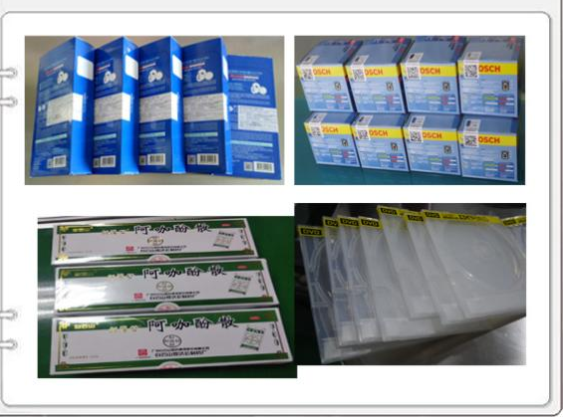
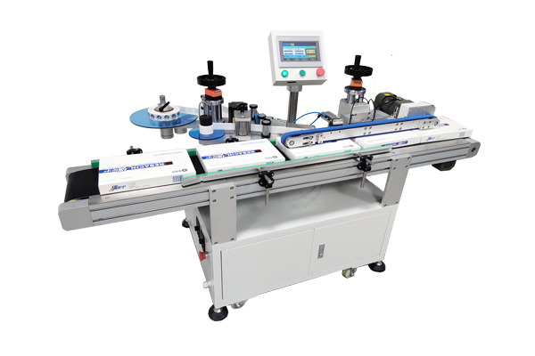

设备用途 Equipment use
专用于盒子转角贴标，在盒子上下平面与侧面转角贴标，起到防拆开作用。主要应用于包装盒的防拆标签贴标。适用产品：各类纸盒，如扑克盒、手机包装盒等各种盒子
Specially used in box corner labeling, in the box upper and lower plane and side corner labeling, to play a role in anti-tampering. Mainly used in the packaging box anti-tampering label labeling. Applicable products: All kinds of paper boxes, such as poker boxes, cell phone boxes and other boxes

3

设备参数 Equipment parameters
以下为标准机型技术参数，其他特殊要求和功能，可量身订做
The following is the standard model technical parameters, other special requirements and functions, can be customized
贴标精度： ±1mm (不含产品、标签误差)；
Labeling accuracy: ±1mm (excluding product, label error);
贴标速度：40～150pcs/min（与产品标签尺寸有关）
Labeling speed: 40 ~ 150pcs/min (related to the size of the product label)
适用标签规格：(L)10mm-150mm;(w)10mm-150mm
Applicable label specifications:(L)10mm-150mm;(w)10mm-150mm
适用产品规格：：（L)40mm-300mm (W)30mm-200mm (H)10mm-100mm
Applicable product specifications（L)40mm-300mm (W)30mm-200mm (H)10mm-100mm
整机尺寸：约（L）2000*(W)850*(H)1450mm（长×宽×高）
Overall machine size: about 2000mm×850mm×1450mm (L×W×H)
适用电源： 110-220V/50HZ；
Applicable power supply: 110-220V/50HZ;
气压（Mpa）：0.4～0.6Mpa
Air pressure (Mpa): 0.4～0.6Mpa
整机重量： 约200Kg。
Weight of the whole machine: about 200Kg.
适用标签内径：Ø76mm
Applicable label inner diameter: Ø76mm
适用标签外径：Ø 300mm
Applicable label outer diameter: Ø 300mm

智能自动双侧面贴标机-T712
Intelligent automatic double side labeling machine-T712
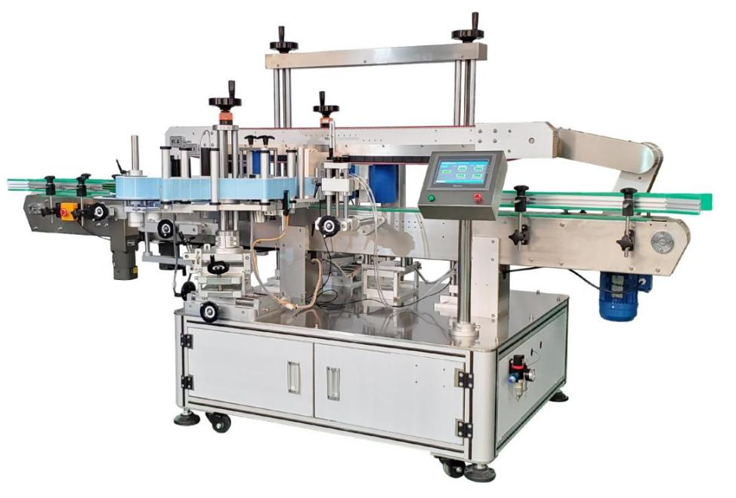
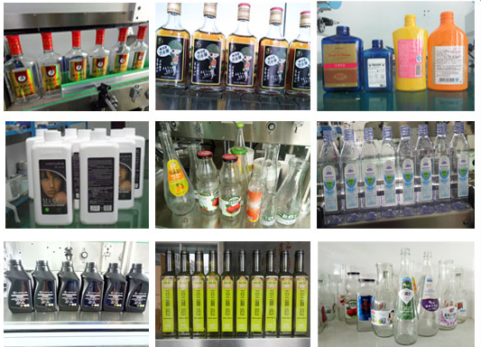

设备用途 Equipment use
本设备适用于 食品、医药、日化、化妆品，精细化工 及其它轻工行业中的稳定可站立 低重心 扁瓶、方瓶、椭圆形瓶、异形瓶、圆瓶或近似圆瓶 包装容器外表面 单侧面、双侧面、圆周自动贴标 .
This equipment is suitable for stable labeling in food, pharmaceutical, daily chemical, chemical products, fine chemical and other light industries Standable Low center of gravity Flat bottle, square bottle, oval bottle, shaped bottle, round bottle or nearly round bottle The outer surface of packaging containers Single side, double side, circumferential automatic labeling .

3

设备参数 Equipment parameters
以下为标准机型技术参数，其他特殊要求和功能，可量身订做
The following is the standard model technical parameters, other special requirements and functions, can be customized
贴标精度： ±1mm (不含产品、标签误差)；
Labeling accuracy: ±1mm (excluding product, label error);
贴标速度；单、双面贴标：40～300件/分钟（与产品、标签尺寸有关）
Labeling speed; Single and double-sided labeling: 40-300 pieces/min (related to the product and label size);
适用标签规格：(L)20mm250mm;(w)20mm-175mm
Applicable label specifications:(L)10mm-250mm;(w)10mm-175mm
适用产品规格：：（L)40mm-300mm (W)30mm-100mm (H)60mm-280mm
Applicable product specifications（L)40mm-300mm (W)30mm-100mm (H)60mm-280mm
整机尺寸：约（L）3000*(W)1450*(H)1600mm（长×宽×高）
Overall machine size: about 3000mm×1450mm×1600mm (L×W×H)
适用电源： 110-220V/50HZ；
Applicable power supply: 110-220V/50HZ;
整机重量： 约300Kg。
Weight of the whole machine: about 200Kg.
适用标签内径：Ø76mm
Applicable label inner diameter: Ø76mm
适用标签外径：Ø 300mm
Applicable label outer diameter: Ø 300mm

RFID智能纸卡贴标机T-118
RFID intelligent paper card labeling machine-T118

Intelligent automatic double side labeling machine-T712

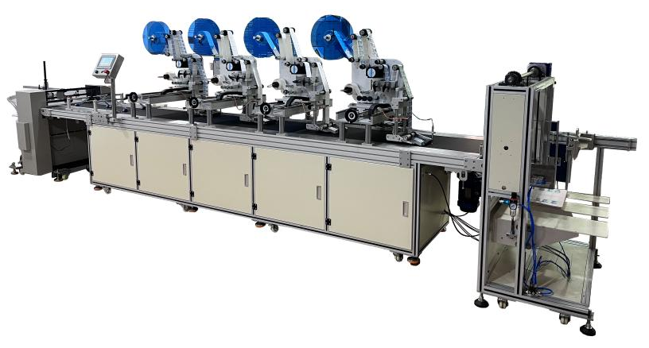
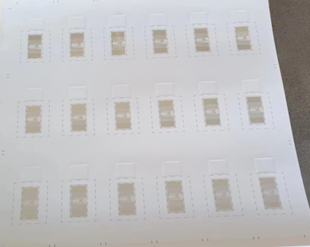

设备用途 Equipment use
专业针对RFID电子标签行业而设计的一款RFID贴标机设备。高速自动RFID标签贴标可贴多排或单排，选用进口伺服电控送标，飞达分料，输送采用吸附式传输产品，自动收料堆叠好，
采用智能彩色触摸屏控制，中英文可选操作页面，方便直观，强大数据记忆功能，可储存50组贴标参数，具有生产计数功能，省电功能，生产数设定提示功能，智能控制，稳定性高：采用进口PLC控制系统，进口伺服电机驱动送标出标，测标、测物传感器采用德国进口一线品牌，检测灵敏度高，性能稳定，自动光电追踪
Professional for RFID electronic label industry and design of a RFID labeling machine equipment. High-speed automatic RFID labeling can be attached to multiple rows or a single row, the choice of imported servo-electric control for labeling, Fei Da dividing material, conveying using adsorption transfer products, automatic receipt of material stacked well.
Using intelligent color touch screen control, Chinese and English optional operation page, convenient and intuitive, powerful data memory function, can store 50 groups of labeling parameters, with production counting function, power saving function, production number setting prompt function, intelligent control, high stability: the use of imported PLC control system, imported servo motor drive to send the label out of the label, measuring the label, measuring the object sensor using German imports of first-class brands, detection sensitivity High, stable performance, automatic photoelectric tracking

3

设备参数 Equipment parameters
贴标精度： ±1mm (不含产品、标签误差)；
Labeling accuracy: ±1mm (excluding product, label error);
贴标速度 ：30～80件/分钟（与产品尺寸有关）；
Labeling speed ： 30～80pieces/min (related to product size);
适用产品尺寸：长度：200mm～550mm 宽度：200mm～520mm （可根据产品定制）
Applicable product size: Length: 200mm～550mm Width: 200mm～520mm (can be customized according to the product)
适用标签尺寸：长度：30mm～100mm 底纸宽度：15mm～100mm
Applicable label size: Length: 30mm ~ 100mm Width of backing paper: 15mm ~ 100mm
整机尺寸： 约6000mm×1200mm×1500mm（长×宽×高）
Overall machine size: 6000mm×1200mm×1500mm (L×W×H)
适用电源： 110-380V/50HZ；
Applicable power supply: 110-380V/50HZ;
气压（Mpa）：0.6～0.8Mpa
Air pressure (Mpa): 0.6～0.6Mpa
整机重量： 约200Kg。
Weight of the whole machine: about 200Kg.
适用标签内径：Ø76mm 适用标签外径：Ø 350mm
Applicable label inner diameter: Ø76mm Applicable label outer diameter: Ø 350mm

高速旋转贴标机T-218
High speed rotary labeling machine T-218

Intelligent automatic double side labeling machine-T712
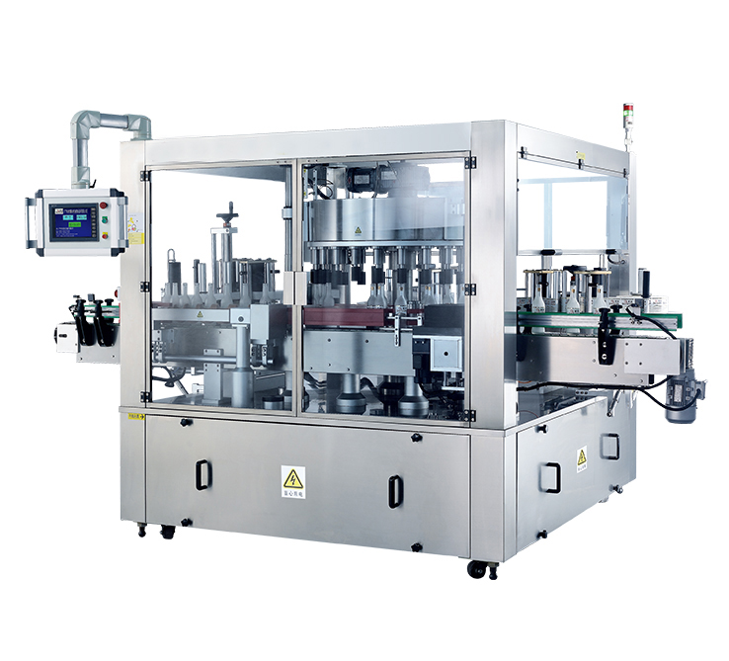

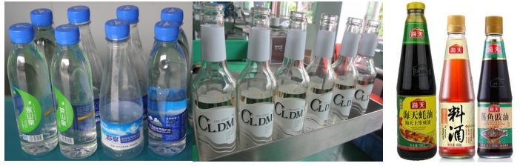

设备用途 Equipment use
本机型适用于扁瓶、方瓶、圆瓶的单侧面、双侧面以及方瓶、圆瓶的三面、四面包围贴标。
可实现产品定位贴标。采用机械式定位，利用容器本身的外观形状，寻找定位点，提高了设备的可靠性。
标头可多维空间调整：标头可实现8维空间调整，倾角调整，各调节机构全部实现快速调节，无需工具，各部件高精度配合，
采用螺杆和星轮配合进瓶出瓶，确保高速运转时，产品进出流畅稳定。
送标采用进口伺服电机，生产速度可达成12000-24000瓶/时，可与高速灌装线连线生产，大大提高了生产速度，节约了生产成本。
This machine is suitable for single-sided and double-sided labeling of flat, square and round bottles as well as three-sided and four-sided surround labeling of square and round bottles.
It can realize product positioning and labeling. Adopting mechanical positioning, using the appearance shape of the container itself to find the positioning point, which improves the reliability of the equipment.
The labeling head can be adjusted in multi-dimensional space: the labeling head can be adjusted in 8-dimensional space, the tilt angle adjustment, all the adjustment mechanism can be quickly adjusted without tools, and the parts are matched with high precision.
Adopt screw and star wheel to cooperate with bottle inlet and outlet to ensure smooth and stable product inlet and outlet when running at high speed.
The label feeding adopts imported servo motor. Production speed can reach 12,000-24,000 bottles / hour, can be linked with high-speed filling line production, greatly improving the production speed and saving production costs.

3

设备参数 Equipment parameters
贴标精度： ±1mm (不含产品、标签误差)；
Labeling accuracy: ±1mm (excluding product, label error);
贴标速度 ：12000～24000件/时（与产品尺寸有关）；
Labeling speed ： 12000～24000pieces/Time (related to product size);
适用标签尺寸：长度：30mm～200mm 底纸宽度：20mm～180mm
Applicable label size: Length: 30mm ~ 200mm Width of backing paper: 20mm ~ 180mm
整机尺寸： 约3000mm×2600mm×2100mm（长×宽×高）
Overall machine size: 3000mm×2600mm×2100mm (L×W×H)
适用电源： 110-380V/50HZ；
Applicable power supply: 110-380V/50HZ;
整机重量： 约200Kg。
Weight of the whole machine: about 200Kg.
适用标签内径：Ø76mm 适用标签外径：Ø 400mm
Applicable label inner diameter: Ø76mm Applicable label outer diameter: Ø 400mm

热熔胶贴标机T-215
Hot melt adhesive labeling machine T-215

Intelligent automatic double side labeling machine-T712
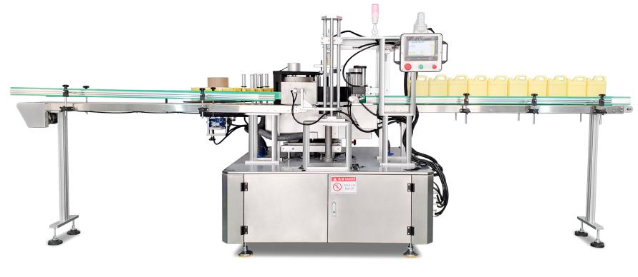
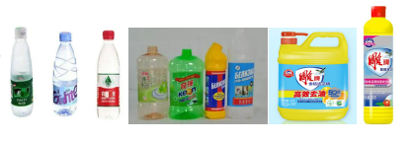

设备用途 Equipment use
1，本机适用于圆·方·扁等柱状容器及瓶型，覆身opp膜，珠光膜，纸塑复合膜，等环周贴标。由于采用非收维性材料，标签印刷图案不会变形，以确保产品包装的美观性，同时也大大降低了包装材料的成本。
2，适用于洗涤，饮料，矿泉水，食品等行业的塑料瓶，玻璃瓶及金属罐等容器的热熔胶贴标。
3，采用伺服电机运用施耐德控制器控制，操作简单，运行稳定可靠。
4，纠偏系统，与先进的上胶系统及真空吸毂完美结合，确保贴标精度高，只在标签的头尾施胶，减少用胶量，节约成本。
5，同步齿轮传动系统，并采用螺杆和星轮配合进出瓶，确保高速运转时，产品进出流畅稳定。
6，生产速度最高可达12000-24000/每小时，可与高速灌装机连线生产，大大提高了生产速度，节约了生产成本
1, this machine is suitable for round - square - flat and other columnar containers and bottle type, cover body opp film, pearl film, paper-plastic composite film, such as ring circumference labeling. Due to the use of non-receiving dimensional materials, the label printing pattern will not be deformed to ensure the beauty of the product packaging, but also greatly reduce the cost of packaging materials.
2, suitable for washing, beverage, mineral water, food and other industries of plastic bottles, glass bottles and metal cans and other containers of hot melt adhesive labeling.
3, using servo motor using Schneider controller control, simple operation, stable and reliable operation.
4, correction system, and advanced glue system and vacuum suction hub perfect combination to ensure high precision labeling, only in the head and tail of the label glue application, reduce the amount of glue, cost savings.
5, Synchronous gear transmission system, and the use of screw and star wheel with the bottle in and out, to ensure high speed operation, the product in and out smooth and stable.
6, Production speed up to 12000-24000 / hour, can be linked with high-speed filling machine production, greatly improving the production speed, saving production costs

3

Equipment parameters
Gluing method: squeegee / spray glue
Labeling method: pre-cut label
Suitable for bottle type: round bottle, square bottle, flat bottle round labeling
Labeling speed: 12000-24000 / hour
Labeling accuracy: ± 1mm
Label maximum length: 750mm label maximum outside diameter: 600 mm
Machine power: about 11kw
Overall machine weight: about 2000kg
Power requirements: 380V 50HZ/60HZ
Air source requirement: 0`6Mpa-0`8Mpa
Glue temperature: 120～160℃
Labeling machine host size:
4650mm(L) X 1650mm(W) X 1650mm(H)

设备参数 Equipment parameters
涂胶方式： 刮胶/喷胶
标签方式： 预切标
适合瓶型：圆瓶,方瓶，扁瓶圆周贴
贴标速度：12000-24000/小时
贴标精度：± 1mm
标签最大长度：750mm 标签最大外径：600 mm
整机功率：约11kw
整机重量：约2000kg
电源要求：380V 50HZ/60HZ
气源要求：0`6Mpa—0`8Mpa
上胶温度：120～160℃
贴标机主机尺寸： 4650mm(长) X 1650mm(宽) X 1650mm(高)

打印贴标机T-120
Printing and labeling machine T-120

Intelligent automatic double side labeling machine-T712
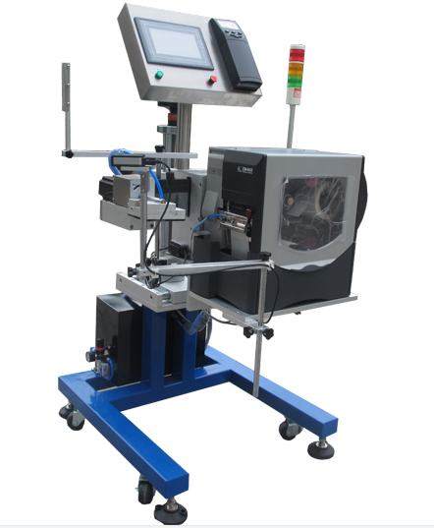
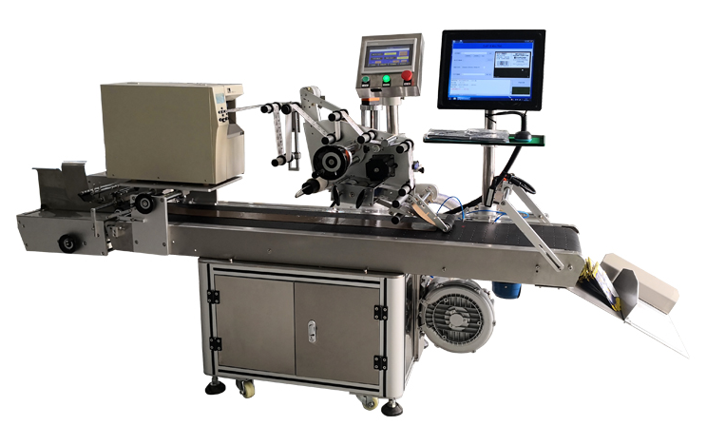

设备用途 Equipment use
1）本机PLC控制打印机， 可与PLC、条码扫描器、机器视觉、称重、检测等设备实时通讯
2）链接客户ERP数据软件，完成标签的制作， 通过ODBC、XML或其它数据接口，可无缝集成到ERP,WMS,WCS等主系统
3）通过传感器检测产品，经过PLC处理信号，贴标位置前后可以通过设置参数来修改。
4）打印信息是电脑通讯控制或其他自动化设备自动生成实时的信息，参数设置，贴标速度，贴标计数一目了然。
技术参数：
打印方式：热转印/热敏
打印分辨率：200dpi 300dpi、600dpi
打印速度：254mm/s
打印范围：宽度 40-120mm; 长度 40-200mm （根据标签尺寸选型）
贴标速度：10-25/分钟
贴标精度：±2mm
供气要求：>0.6 Mpa
打印内容：文字、流水号、日期、图案、一（二维）条形码等标识。
1) PLC control of printer, real-time communication with PLC, barcode scanner, machine vision, weighing, testing and other equipment
2）Link with customer ERP data software to complete the label production, through ODBC, XML or other data interfaces, can be seamlessly integrated into ERP, WMS, WCS and other main systems
3) Through the sensor to detect the product, after the PLC processing signal, the labeling position before and after can be modified by setting parameters.
4）Printing information is computer communication control or other automatic equipment to automatically generate real-time information, parameter settings, labeling speed, labeling count at a glance.
Technical parameters:
Printing method: thermal transfer / thermal
Print resolution: 200dpi 300dpi, 600dpi
Print speed: 254mm / s
Printing range: width 40-120mm; length 40-200mm (according to the label size selection)
Labeling speed: 10-25 / min
Labeling accuracy: ± 2mm
Air supply requirements: > 0.6 Mpa
Print content: text, running number, date, pattern, a (two-dimensional) bar code and other identification.

3

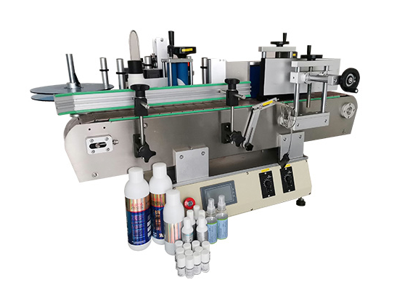
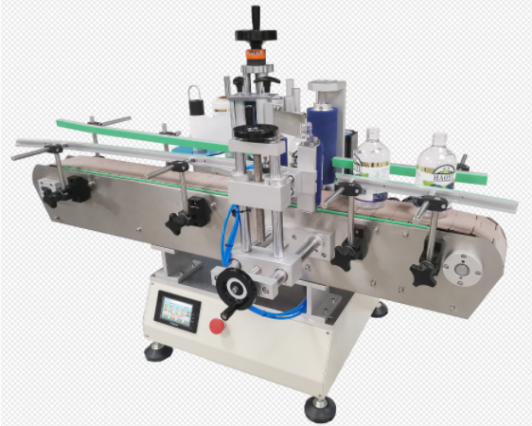
桌面式圆瓶贴标机-T213
Desktop type round bottle labeling machineT213

设备用途 Equipment use
本设备主要针对规则圆瓶且材质较硬不易变形的产品贴标，如化妆品、食品、医药、日 化、电子、玩具、五金、塑胶等行业中，规则类产品大小兼容范围广，贴标效率高。适用圆瓶，四方瓶，六角瓶等贴标。
可选 配色带打码机和喷码机，贴标同时实现打印生产批号、生产日期等信息，实现贴标-喷码一体化，减少包装工序， 提高生产效率。适用不干胶标签、不干胶膜、电子监管码、条形码、二维码标签、透明标签等。设备稳定性高、贴标效果好，无气泡、无褶皱，贴标精度±1mm
The equipment is mainly for regular round bottles and hard material is not easy to deform the product labeling, such as cosmetics, food, medicine, daily chemical, electronics, toys, hardware, plastic and other industries, the size of regular products compatible with a wide range, labeling efficiency. Suitable for labeling round bottles, four-sided bottles, hexagonal bottles, etc.
Optional ribbon coding machine and printing machine, labeling at the same time to print the production batch number, production date and other information, labeling - printing code integration, reduce the packaging process, improve production efficiency. Suitable for self-adhesive labels, self-adhesive film, electronic supervision code, bar code, two-dimensional code labels, transparent labels, etc. High stability of equipment, good labeling effect, no bubble, no wrinkle, labeling accuracy ±1mm

设备参数 Equipment parameters
贴标精度： ±1mm (不含产品、标签误差)；
Labeling accuracy: ±1mm (excluding product, label error);
贴标速度：20～100pcs/min（与产品标签尺寸有关）
Labeling speed: 20 ~ 100pcs/min (related to the size of the product label)
适用标签规格：(L)20mm-200mm;(w)20mm-150mm
Applicable label specifications:(L)20mm-200mm;(w)20mm-150mm
适用产品规格：：Ø 25mm～Ø 100mm；（可根据样品定做）
Applicable product specifications: Ø 25mm～Ø 100mm; (can be customized according to samples)
整机尺寸：（L）1200*(W)650*(H)750mm（长×宽×高）
Overall machine size: about1200mm×650mm×750mm (L×W×H)
适用电源： 110-220V/50HZ；
Applicable power supply: 110-220V/50HZ;
整机重量： 约120Kg。
Weight of the whole machine: about 180Kg.
适用标签内径：Ø76mm 适用标签外径：Ø 300mm
Applicable label inner diameter: Ø76mm Applicable label outer diameter: Ø 300mm

侧面流水线贴标头-T512
Side line labelling head-512
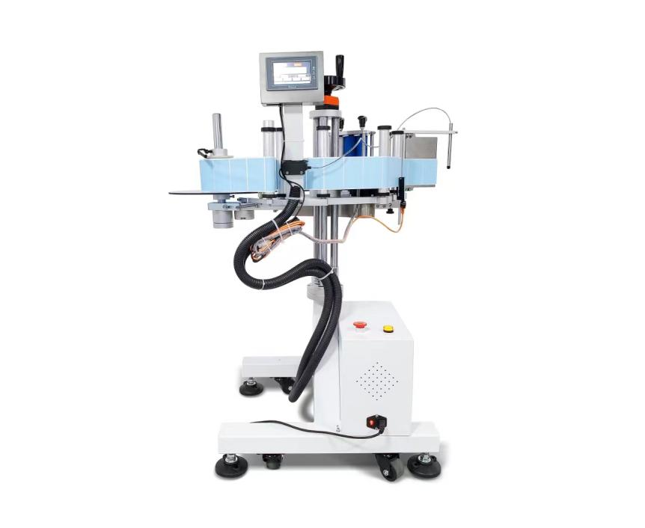
设备用途 Equipment use
滚贴贴标头适用于在各种物品的上平面贴标签或不干胶膜，如书本、文件夹、盒子、纸箱等，更换覆标机构可适用于不平整表面贴标，广泛应用于大件产品的平面贴标，规格范围大的平面类物体贴标。
可选配打码机或喷码机到贴标头，可实现在标签上打印生产日期、批号和喷印条码等信息
Roll sticker labelling head is suitable for labelling or self-adhesive film on various items, such as books, folders, boxes, cartons, etc. Replacement of the over-labelling mechanism can be applied to uneven surface labelling, widely used in large products flat labelling, specification range of large flat objects labelling.
Optional coder or printer to the labelling head, can be achieved in the label printing date of production, batch number and printing bar code and other information.

设备参数 Equipment parameters
以下为标准机型技术参数，其他特殊要求和功能，可量身订做
The following is the standard model technical parameters, other special requirements and functions, can be customized
贴标精度： ±1mm (不含产品、标签误差)；
Labeling accuracy: ±1mm (excluding product, label error);
贴标速度；40～200件/分钟（与产品、标签尺寸有关）
Labeling speed; 40-200 pieces/min (related to the product and label size);
适用标签规格：(L)20mm250mm;(w)20mm-175mm
Applicable label specifications:(L)10mm-250mm;(w)10mm-175mm
适用产品规格：：（L)40mm-400mm (W)30mm-500mm (H)60mm-380mm
Applicable product specifications（L)40mm-400mm (W)30mm-500mm (H)60mm-380mm
整机尺寸：约（L）1100*(W)700*(H)1000mm（长×宽×高）
Overall machine size: about 1100mm×700mm×1000mm (L×W×H)
适用电源： 110-220V/50HZ；
Applicable power supply: 110-220V/50HZ;
整机重量： 约180Kg。
Weight of the whole machine: about 180Kg.
适用标签内径：Ø76mm
Applicable label inner diameter: Ø76mm
适用标签外径：Ø 300mm
Applicable label outer diameter: Ø 300mm

上平面流水线贴标头-T511
Upper plane assembly line labelling head-T511

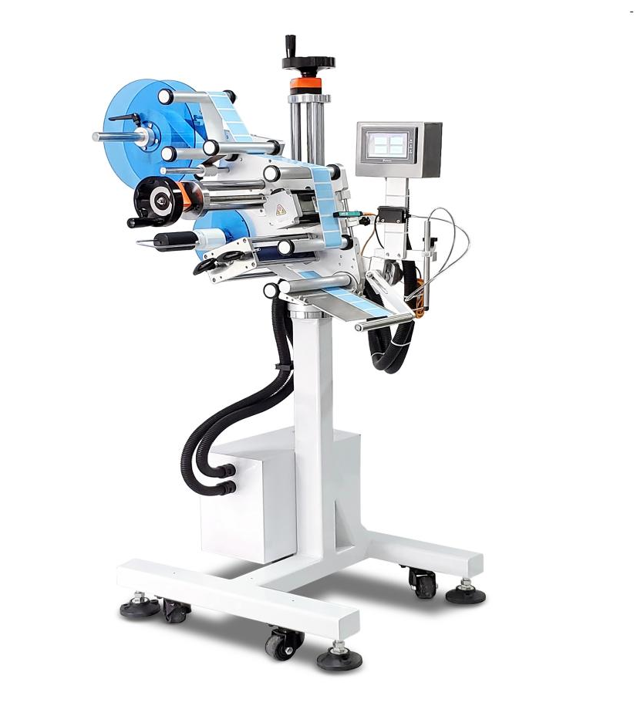
设备用途 Equipment use
滚贴贴标头适用于在各种物品的上平面贴标签或不干胶膜，如书本、文件夹、盒子、纸箱等，更换覆标机构可适用于不平整表面贴标，广泛应用于大件产品的平面贴标，规格范围大的平面类物体贴标。
可选配打码机或喷码机到贴标头，可实现在标签上打印生产日期、批号和喷印条码等信息
Roll sticker labelling head is suitable for labelling or self-adhesive film on various items, such as books, folders, boxes, cartons, etc. Replacement of the over-labelling mechanism can be applied to uneven surface labelling, widely used in large products flat labelling, specification range of large flat objects labelling.
Optional coder or printer to the labelling head, can be achieved in the label printing date of production, batch number and printing bar code and other information.

设备参数 Equipment parameters
以下为标准机型技术参数，其他特殊要求和功能，可量身订做
The following is the standard model technical parameters, other special requirements and functions, can be customized
贴标精度： ±1mm (不含产品、标签误差)；
Labeling accuracy: ±1mm (excluding product, label error);
贴标速度；40～300件/分钟（与产品、标签尺寸有关）
Labeling speed; 40-300 pieces/min (related to the product and label size);
适用标签规格：(L)20mm250mm;(w)20mm-175mm
Applicable label specifications:(L)10mm-250mm;(w)10mm-175mm
适用产品规格：：（L)40mm-400mm (W)30mm-500mm (H)60mm-380mm
Applicable product specifications（L)40mm-400mm (W)30mm-500mm (H)60mm-380mm
整机尺寸：约（L）1100*(W)700*(H)1000mm（长×宽×高）
Overall machine size: about 1100mm×700mm×1000mm (L×W×H)
适用电源： 110-220V/50HZ；
Applicable power supply: 110-220V/50HZ;
整机重量： 约180Kg。
Weight of the whole machine: about 180Kg.
适用标签内径：Ø76mm
Applicable label inner diameter: Ø76mm
适用标签外径：Ø 300mm
Applicable label outer diameter: Ø 300mm

盖子+圆瓶贴标机-T214
Cap + round bottle labeling machine-T214

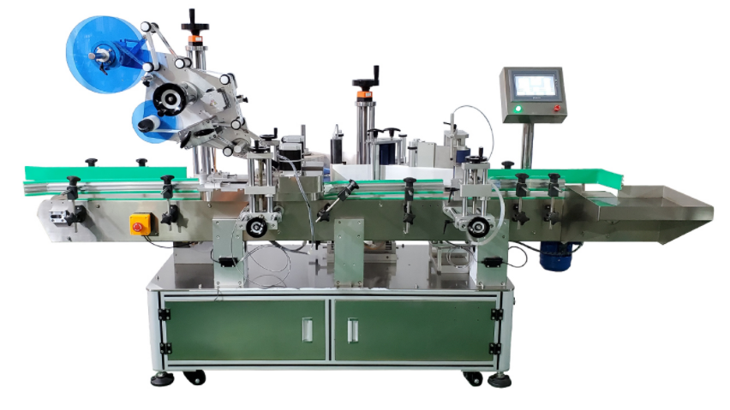

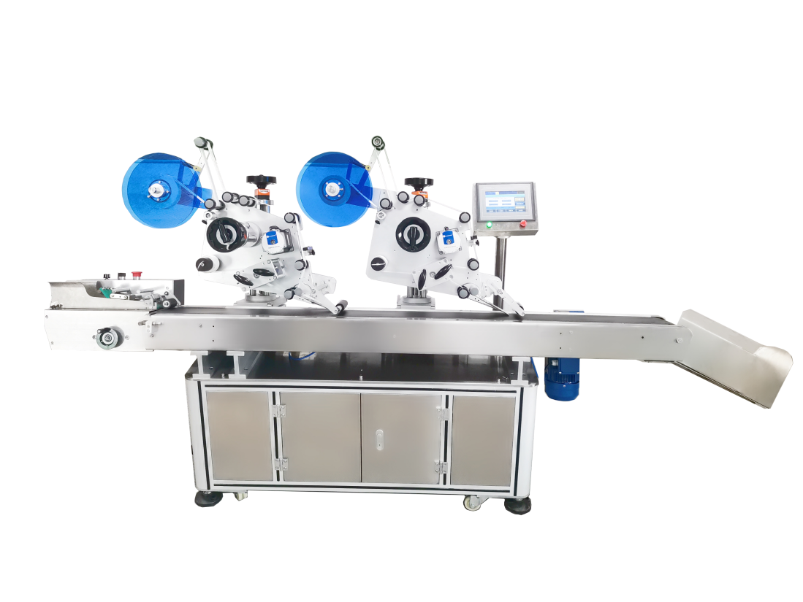

双头圆瓶贴标机-T216
Double-headed round bottle labeling machine-T213

双标头分卡贴标机-T114
Double label head split card labeling machine-T114

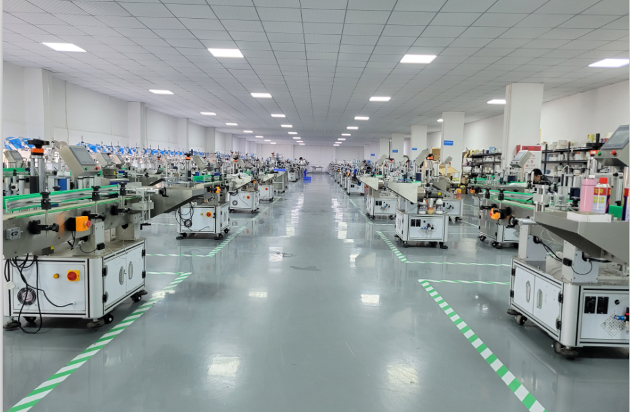

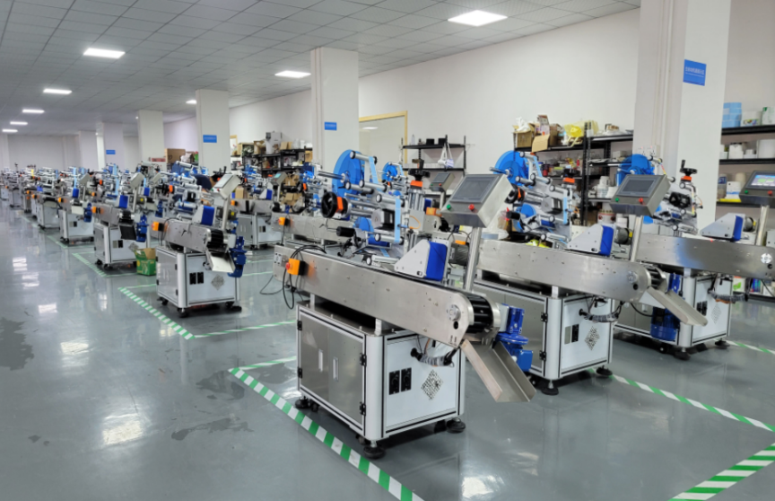


Thank you for your patience

感谢您的耐心
Thank you for your patience

Thank you for your patience
Thank you for your patience
Thank you for your patience

Thank you for your patience

Thank you for your patience观看
Thank you for your patience in watching
真诚与您携手，共创企业美好未来！
Sincerely join hands with you to create a better future for the enterprise!

